Feedback Form, V1.0

Interim Code of Conduct for Responsible Carbon Finance for Clean Cooking

# RCF Principles and Code of Conduct Background

# Background on the Principles and formation of the Code of Conduct

CCA’s [Principles for Responsible Carbon Finance in Clean Cooking](https://cleancooking.org/wp-content/uploads/2024/05/The-Principles-for-Responsible-Carbon-Finance-in-Clean-Cooking.pdf) (RCF) focus on integrity, transparency, fairness, and sustainability. The Principles serve to guide responsible conduct and enhance the confidence that buyers, investors, households, and governments have in clean cooking carbon markets.

​The Principles, which more than 100 organizations have already committed to, are the product of an extensive public process initiated by CCA in 2023, with input from hundreds of stakeholders engaged in climate finance and clean cooking. The Principles were developed through two public consultations that involved 359 stakeholders from 267 institutions, followed by review and approval by eight co-chairs. Earlier this month, the final draft was then endorsed, through majority consent, by the [RCF Advisory Council](https://cleancooking.org/industry-development/carbon-and-innovative-finance/the-responsible-carbon-finance-for-clean-cooking-initiative/responsible-carbon-finance-advisory-council/), a group of 14 senior stakeholders from the clean cooking and carbon finance sectors, convened by CCA.

​

​​*Figure 1: Overview of the Principles for delivering responsible carbon finance to clean and improved cooking.*

The intention when creating the Principles was to eventually develop them into a voluntary Code of Conduct that will set out the essential elements of high-quality carbon financing in the sector. Ultimately, the intention is to guide actions that build buyers’ confidence in the delivery of responsible, high-quality carbon credits from the clean and improved cooking sector.

## Purpose of the Code of Conduct

### For the market to scale with integrity, carbon finance must be deliverable responsibly, based on sound, up-to-date scientific data and realistic, verifiable assumptions. Transparency and fairness in the delivery of carbon finance are equally important, as is nurturing favorable investment environments that allow clean and improved cooking markets to scale sustainably.

### A coordinated approach is therefore needed to ensure that clean and improved cooking activities certified in the carbon market deliver the high-quality carbon credits that buyers expect. To this end, this Interim Code of Conduct outlines the actions that project developers must take to fulfil the Principles for Responsible Carbon Finance, shown in Figure 1. Doing so helps build the underlying conditions of trust and confidence needed for this market to flourish, and gives buyers confidence in the quality of the programs they invest in.

### The actions outlined in this Interim Code of Conduct are designed to complement existing actions and fill gaps where they exist, and​​ raising ambition where it is lacking. They do not aim to replace other valuable initiatives working on quality issues in the broader carbon market including the Integrity Council for the Voluntary Carbon Market (ICVCM), the carbon standards, and the International Carbon Reduction and Offset Alliance (ICROA); rather, they are designed to build on them with details that are specific to the clean and improved cooking sector and are too granular for broader initiatives to cover.

​​​

This Interim Code of Conduct was developed between July and November 2024, with the Advisory Council endorsing it for public consultation in December 2024. It was informed by a series of consultations with dedicated working groups from across clean and improved cooking markets, including a diverse range of stakeholders representing project developers; investors; climate financiers; carbon standards; nongovernmental organizations; market facilitators; service providers; and carbon credit buyers, sellers, and intermediaries. The Interim Code of Conduct was also informed by expert interviews, and desk-based research conducted by Climate Focus, a climate and carbon consultancy contracted by CCA.

​​*Figure 2: Overview of the development of the Code of Conduct*

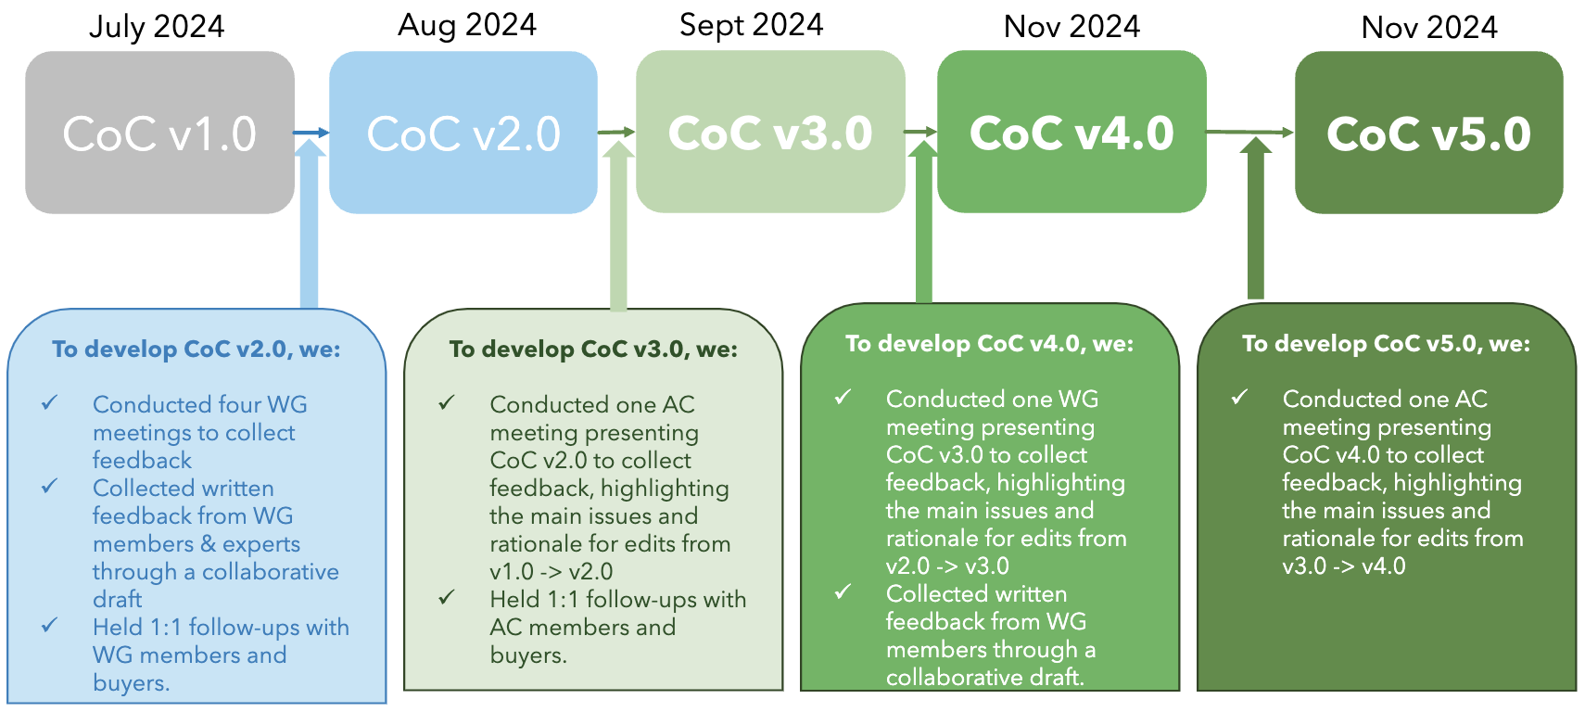

### Next Steps and Timeline

Having developed an Interim Code of Conduct, CCA welcomes broader stakeholder feedback and

input through this open channel for feedback. This consultation window will be open from 5th February to 9th April 2025.

CCA’S [RCF Advisory Council](https://cleancooking.org/industry-development/carbon-and-innovative-finance/the-responsible-carbon-finance-for-clean-cooking-initiative/responsible-carbon-finance-advisory-council/) will review and approve suggested changes that will be submitted during the consultation window. Following this revision process, the Interim Code of Conduct will be referred to simply as “the Code of Conduct.”

This document is intended for two key audiences:

* **Carbon project developers:** This Code of Conduct outlines the actions needed to meet each Principle.
* **Carbon credit buyers and investors:** This Code of Conduct provides guidance on what to look for in practice when supporting project developers that meet the Principles for responsible carbon finance.

​​*Figure 3: Overview of the 2025 work plan for the Code of Conduct*

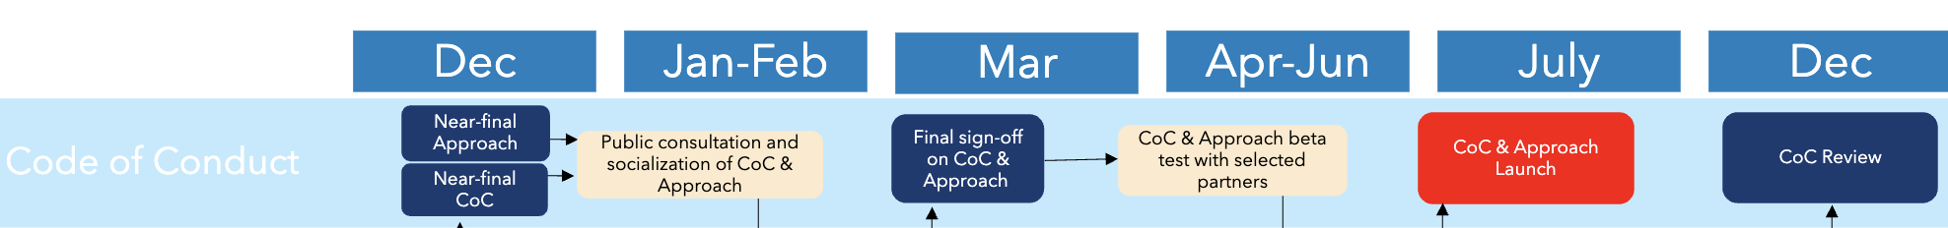

### The Interim Code of Conduct

The Interim Code of Conduct for Responsible Carbon Finance for Clean Cooking can be viewed [here](https://drive.google.com/file/d/12WvGPRdCMJ7D9tO8tEqd-BR0N0gNgeb5/view?usp=drive_link).

Feedback Section

# Feedback

# Guidance

* Please send in one document per organization.
* You do not have to reply to all sections of the Interim Code of Conduct.
* Please send this document to carbon@cleancooking.org by 9th April 2025.
* Please note that any response you provide is confidential and in no way binding.

# Feedback Form

**Name of commenter**:  
**Best email for follow-up questions**:

**Organization**:

**Date**:

Note: please use document page numbers for all comments to the extent possible. Please add lines to the table below as needed.

|  |  |  |  |  |
| --- | --- | --- | --- | --- |
| **Pg**  **#** | **Section, sub-section,** **figure or table #** | **Comment type1** | **Comment** | **Proposed change (if any)** |
|  |  |  |  |  |
|  |  |  |  |  |
|  |  |  |  |  |
|  |  |  |  |  |
|  |  |  |  |  |
|  |  |  |  |  |
|  |  |  |  |  |
|  |  |  |  |  |
|  |  |  |  |  |
|  |  |  |  |  |
|  |  |  |  |  |
|  |  |  |  |  |
|  |  |  |  |  |
|  |  |  |  |  |
|  |  |  |  |  |
|  |  |  |  |  |
|  |  |  |  |  |
|  |  |  |  |  |
|  |  |  |  |  |
|  |  |  |  |  |
|  |  |  |  |  |
|  |  |  |  |  |

**Type of commen**t: **ge** = general **te** = technical **ed** = editorial